1. Project Overview
This document outlines the planning and timeline for the AI-powered hotel reservation project, detailing key phases, activities, and deliverables. It ensures coordinated execution, efficient resource use, and adherence to timeline and quality standards.

2. Sprint Breakdown
Sprint 1: Core Authentication & Home Page
Duration: 1-2 weeks
Objectives:
- Lay the foundation for secure user access and a user-friendly interface.
Key Tasks:
- Design Registration/Login UI:
Create detailed wireframes and mock-ups for registration and login screens.
- Implement Authentication:
Code the core authentication functionalities using Laravel’s built-in features.
- Email Verification Flow:
Set up an email verification process to validate newly registered user account.
- Basic Search Bar + Filters:
Develop a simple search interface on the home page that accepts user inputs (keywords, destination, date, etc.) and supports basic filtering (price range, star rating).
Expected Milestones:
- Completion and internal testing of the authentication module.
- Functional email verification.
- Working basic search bar that responds to user inputs.

Sprint 2: AI & API Integration
Duration: 2 weeks
Objectives:
- Enhance the home page by integrating external data and intelligent recommendation capabilities.
Key Tasks:
- Integrate Hotel Data APIs:
Establish stable connections with providers (e.g., docs.hotelapi) to fetch current hotel.
- Build AI Recommendation Engine:
AI module that uses booking history to deliver personalized hotel recommendation.
- Dynamic Sorting/Filtering:
Enhance search with dynamic sorting and filters using live API data and AI insights to.
Expected Milestones:
- A prototype of the AI recommendation engine that offers personalized hotel options.
- Enhanced search results reflecting dynamic sorting and filtering capabilities.

Sprint 3: Dashboard & Security
Duration: 3–4 weeks
Objectives:
- Develop dedicated dashboards for both end users and administrators.
- Strengthen the system’s security posture as additional functionalities are layered on.
Key Tasks:
- User Dashboard Development:
Create a dashboard for users to view bookings, manage profiles.
- Admin Dashboard Development:
Build an admin interface to manage users, handle reservations, and adjust pricing.
Expected Milestones:
- Full implementation of both user and admin dashboards.
- Successful integration of additional security measures.
Sprint 4: Mobile & Final Testing
Duration: 2–3 weeks
Objectives:
- Ensure a seamless experience across all devices, finalize testing, and prepare the system for deployment.
Key Tasks:
- Mobile-Responsive UI:
Refine the UI for mobile with responsive design for optimal usability.
- End-to-End Testing:
Conduct unit, integration, and user acceptance tests.
- Bug Fixes & Deployment Preparation:
Fix any bugs found during testing, finalize user documentation, and prepare the system for production deployment.
Expected Milestones:
- Verification of mobile responsiveness across a range of devices.
- Approval of system performance through end-to-end testing.

3. Team Roles
- Student Ahmad:
Managed documentation, workflow planning, and requirements gathering (both functional & non-functional).
- Student Abdulsalam:
Handled frontend feasibility analysis ensuring a responsive and accessible UI.
- Student Talal:
Researched API compatibility and backend architecture, also contributing significantly to requirements gathering.

3. Gantt Chart
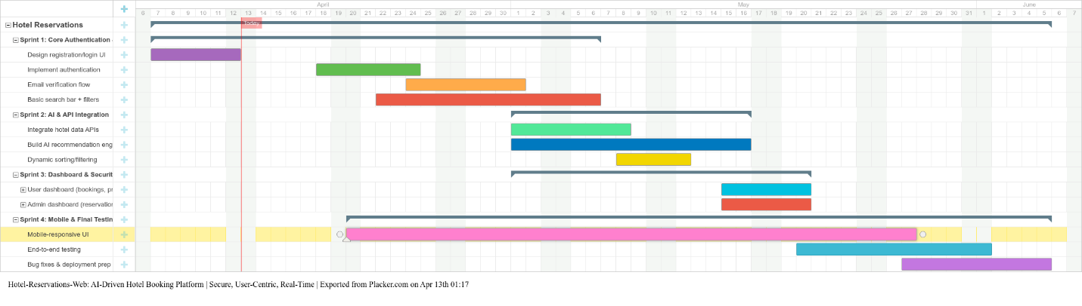
Figure 1: Project Gantt Chart

